THE UNIVERSITY OF TEXAS RIO GRANDE VALLEY
COLLEGE OF COMPUTER SCIENCE & ENGINEERING
DEPARTMENT OF MECHANICAL ENGINEERING
HEATED CALENDERING SYSTEM

SENIOR DESIGN I REPORT
DECEMBER 2017

PREPARED BY:
JOSE MAYORGA
LUIS GALLEGOS
DAVID DE LA GARZA
Your Names
PREPARED FOR:
FACULTY ADVISOR:
Dr. …………
COURSE ADVISOR:
Dr. Kamal Sarkar

Abstract (About a page & not to exceed a page and half)
This report will be based of the designing of a lab sized calendering machine. In the industry companies makes thousands of feet in thin-filmed material ranging from many different materials such as PVC, Rubber, Woven material, etc. the list goes on and on, but the problem is there are not many calendering machines that are not industrial sized to produce small films for purposes of research facilities whom wish to test mechanical properties to do research. Even with some of the smaller machines that do exist they are still very big and are limited to there capabilities. There is a small percentage of the industry that captures the business of small calendering machines where our product would be competing in. Some background research will be discussed to gain incite into calendering machines. Then there will be an understanding of the actual market place. The goals, objectives, and constraints of this machine will be stated with one of the major points is to be portable and lightweight. A tool known, as a QFD will be used to compare competitor products to needs/wants of the customer and matching them to engineering specifications needed for the machine to be operational. Once a good understanding of what is needed of the product to work and the competitors that our product will be competing against the concept development of the product can begin. Breaking down the product into its separate parts and components such as the rollers, temperature controllers, speed controller, and frame for the system. From here one can go into the selection process of components need to get an initial mock up design with some dimensions. Then one can under go the design embodiment of the calendering machine where engineering calculations are derived and set with standards to solve the problems for the calendering machine. ……….

Table of Contents
I. Abstract 2
II. Table of Contents 4
III. List of Figures 6
IV. List of Tables 7
V. Problem Formulation 8
V A. Introduction (“Elevator Speech”) 8
V B. Background Research 9
V C. Competitive Products 13
V D. Needs & Wants 17
V E. Goals & Objectives 18
V F. Constraints 19
V G. QFD 19
VI. Concept Development 28
VI A. Methodology 28
VI B. Functional Decomposition 28
VI C. Sub-function I Heated Roller 30
VI C1. Heat Roller Design Constraints 31
VI C2. Heat Roller Concept Variants 32
VI C3. Heated Roller Selection Process & Identifying Winning Selection 35
VI D. Sub-function II Gaping Sensor 36
VI D1. Gaping Sensor Design Constraints 37
VI D2. Gaping Sensor Concept Variants 37
VI D3. Gapping Sensor Selection Process & Identifying Winning Selection 40
VI F. Sub-function IV Thermo-Sensors 41
VI F1. Thermo-Sensors Design Constraints 41
VI F2. Thermo-Sensors Concept Variants 42
VI F3. Thermo-Sensors Selection Process & Identifying Winning Selection 44
VI H. 3D Rendering of the Proposed Design, Complete with Dimensional Detail 45

VII J Conceptual Designs based on Winning Selections
VII K Final Winning Design
VII L Complete SolidWorks Design with Dimensions and Two & Three D Views

VII. Design Embodiment 46
VII A. Engineering Analysis 46
VII A1. Identification of Core Engineering Topics & Related Equations 47
VII A2. Engineering Analysis complete with Tables & Graphs 49
VII A3. Engineering Analysis complete with Tables: Machine Elements 52
VII A4. Software (Algor, Working Model, MatLab, etc) _____________________________________
VII A5. Customized Software Developed, If Any __________________________________________
VII A6. Preliminary Experimental Data, If Any ____________________________________________
VIII. Design for X (Manufacturability, Reliability, Environment, Safety, Sustainability, etc.)
VIII B. Design for Manufacturability 57
VIII B1. Preparing Parts & Components 57
VIII B2. Assembly Process 62
VIII B3. Manufacturing Process Document 65
VIII C. Design for Environment __________________________________________________________
VIII C1. Environmental impact on Raw Materials, Parts & Components, etc.
VIII C2. Environmental Impact of using the Product with Resources Needed
VIII C3. Does the Product Address any Environmental Issue? Elaborate.
VIII D. Design for Safety _________________________________________________________________
VIII D1. Safety Issues Related to Product Usage
VIII D2. Safety Features Built-in into the Product
VIII D3. Does the Product Address Any Safety Concern? Elaborate. _________________________
IX. Bill of Materials 65
X. Engineering Economics
X A. Prototype Cost_________________________________________________________________
X B. Product Volume, Product Cost, & Market Size ________________________________________
XI. Design Validation 66
XI A. Product Drawings with Dimensions & Two and Three D Views with Relative Size ______________
XI B. DFMEA (Design Failure Modes & Effects Analysis) ____________________________________
XI C. PFMEA (Process Failure Modes and Effects Analysis) __________________________________
XI D. Test Protocols _________________________________________________________________
XI D1. Test Templates ____________________________________________________________
XI D2. Sample Raw Data __________________________________________________________
XI D3. Data Analysis (Procedure, Sample Analysis, & Sample Output) ______________________
XI D4. Graphical Output for Various Data ____________________________________________
XI D5. Proposed What-If Scenarios _________________________________________________
XI E. Quality Controls
XI E1. QC for Raw Materials, Parts, & Components _______________________________
XI E 2. Performance Analysis at Product/System Level _____________________________
XI F. Safety Features _______________________________________________________________
XI F1. Material Handling at Parts & Components Level __________________________________
XI F2. Product Handling during Shipping & Handling ____________________________________
XI F3. Safety Features for Operations & Maintenance ___________________________________
XII. References
XIII. Appendices

Test Protocols 66
X C. Economic Analysis 67
IX C1. Production Cost 67
X. Summary 68
XI. Reference: 69

List of Figures
Figure 1 VB: Market prediction for calendering products
Figure 2 VB: (a) “I” arrangement rollers (b) “L” arrangement rollers (c) “Z” arrangement rollers
Figure 1. V C : Guangyue Calendaring System
Figure 2 V C : CT Multi Roll
Figure 3 VC Roller Configuration
Figure 3. V C : CT Two-Roll Mill
Figure 4 V C : Gelon Calendering System
Figure 1 VG: (a) Simplified view of a QFD (b) Actual QFD to evaluate Calendering Systems
Figure 2 VG: Customers Needs/Wants Correlated to Engineering Specifications and Competitor Products
Figure 3 VG: Shows the relationship between the engineering specifications
Figure 4 VG: Competitor Products Detailed Engineering Specifications
Figure 5 VG: (a) I-Roller Arrangment (b) Z-Roller Arrangment
Figure 1 VI B: Conceptual Design of a Calendering Machine
Figure 2 VI B: Conceptual Design Break Down
Figure 1 VI C3: Custom Heated Roller
Figure 1 VI D3 : Vernier Caliper
Figure 1. VI F3 : Thermistor Sensor
Figure V1 H1: Initial Design
Figure V1 H2: Dimensions
Figure 1 VII A2: Heated roller with resistance of thermal conductivity
Figure 2 VII A2: Heat transfer calculation
Figure VII A3: two gears in contact
Figure1 VII B1: Steel and Aluminum Rods
Figure 2 VII B1: Aluminum Rod Drawing
Figure 3 VII B1: Steel Rod
Figure 4 VII B1: Drilling out the steel rod
Figure 5 VII B1: Boring out steel rod
Figure 6 VII B1: Other end turned down to 0.5 inches
Figure 1 VII B2: Aluminum Rod Completed
Figure 2 VII B2: Aluminum rod with grease gun
Figure 3 VII B2: Steel Roller with thermal grease
Figure 4 VII B2: Completed Heated Roller

List of Tables
Table 1 VI C1 : Design Criteria for Heated Rollers
Table 2 VI C2 : Concept Variants with Respect to Cost
Table 3 VI C2 : Concept Variants with Respect to Sensitivity
Table 4 VI C2 : Concept Variants with Respect to Range
Table 5 VI C2 : Concept Variants with Respect to Durability
Table 6 VI C3 : Concept Variants with Respect to Durability
Table 1 VI D1 : Design Criteria for Gap Sensors
Table 2 VI D2 : Concept Variants with Respect to Cost
Table 3 VI D2 : Concept Variants with Respect to Sensitivity
Table 4 VI D2 : Concept Variants with Respect to Range
Table 5 VI D2 : Concept Variants with Respect to Durability
Table 6 VI D3 : Selection Process of Gap Sensors
Table 1. VI F1 : Design Criteria for Temperature Sensors
Table 2. VI F2 : Concept Variants with Respect to Sensitivity
Table 3. VI F2 : Concept Variants with Respect to Range
Table 4. VI F2 : Concept Variants with Respect to Accuracy
Table 5. VI F2 : Concept Variants with Respect to Cost
Table 6. VI F3 : Selection Process of Temperature Sensors
Table 1 VII A1: Equation used for Engineering Analysis
Table V11 A1: Calculated values for gear analysis
Table VIII: Bill of Materials

Figure 1 VB: Market prediction for calendering products
Figure 1. V C : Guangyue Calendaring System
plastic and rubber. The max roll temperature reaches up to 180°C.

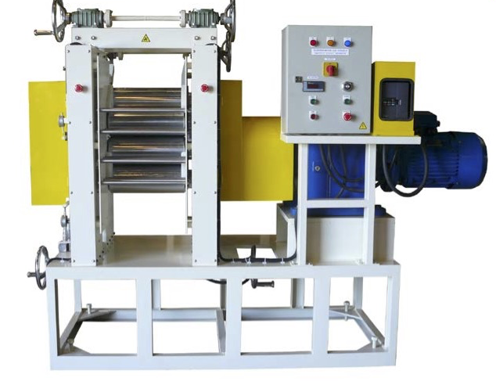
Figure 2 VC : CT Multi Roll

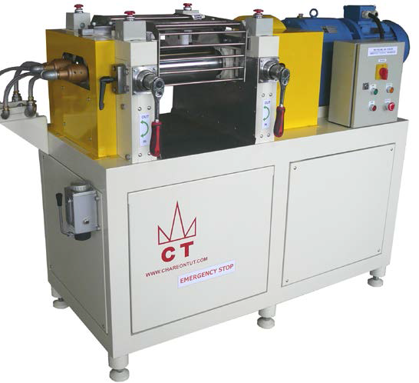
Figure 4 VC : CT Two-Roll Mill

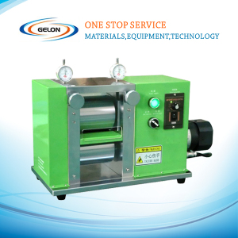
Figure 5 V C : Gelon Calendering System

V D. Needs & Wants

E. Goals & Objectives

V F. Constraints

V G. QFD
The QFD was constructed to see how the need and wants of the customer are related to the engineering specification and how each one of them have a strong relationship with each other. Also, the QFD shows the competitive products in the market and it compares each competitive product with each other and also against our product. The customers needs and wants are related and is in the middle of the QFD. The whole QFD is explained but it will be broken down into sections so it can be clarified in greater detail with figures to help with the explination.

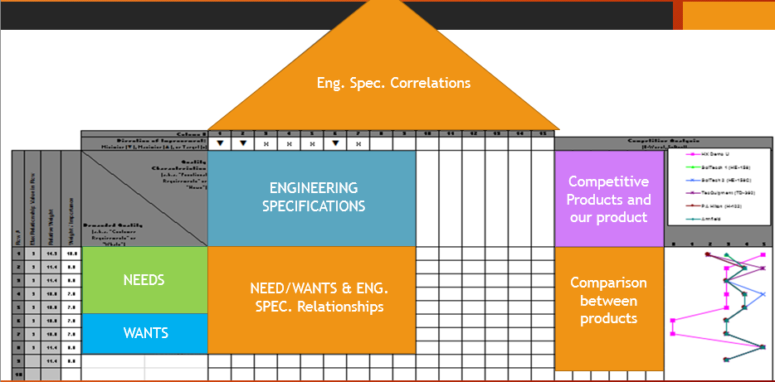
(a)
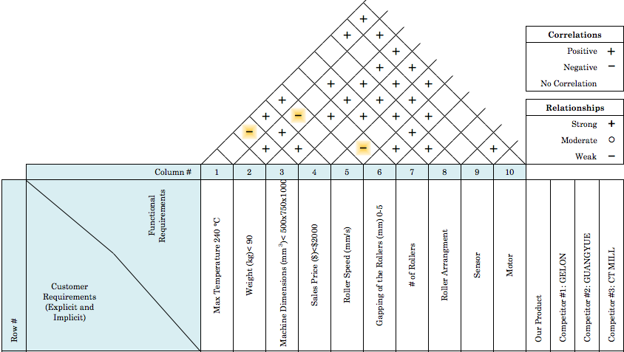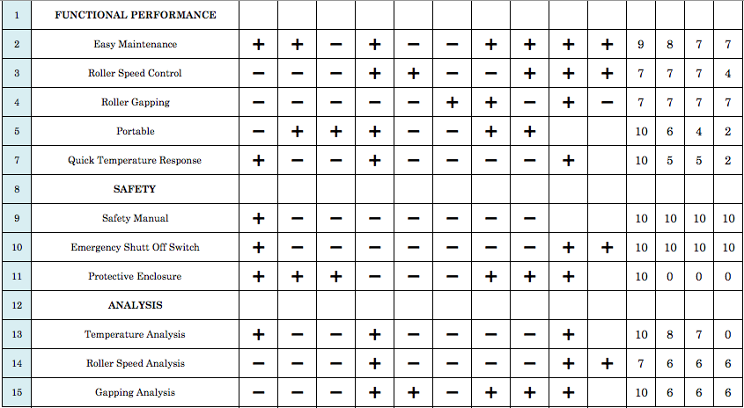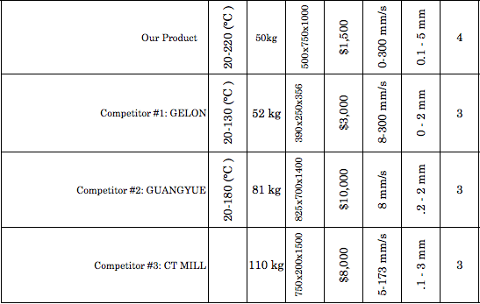
(b)
Figure 1 VG: (a) Simplified view of a QFD (b) Actual QFD to evaluate Calendering Systems

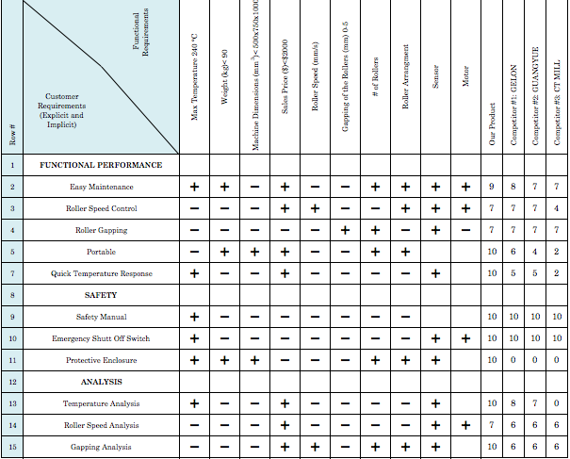
Figure 2 VG: Customers Needs/Wants Correlated to Engineering Specifications and Competitor Products

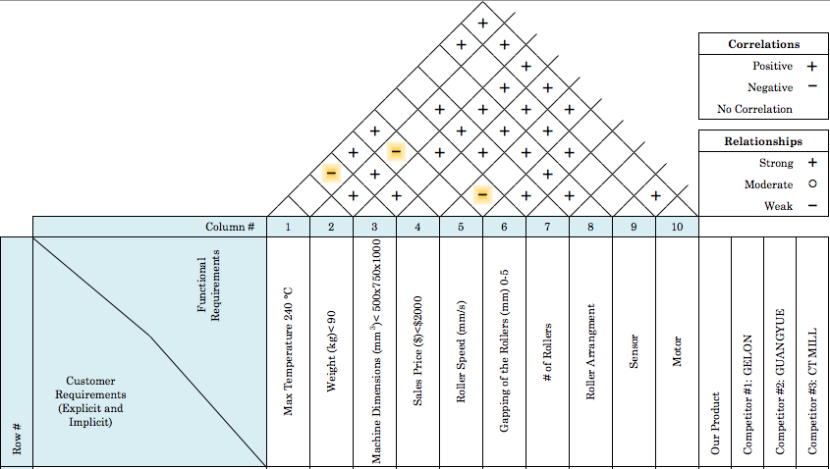
Figure 3 VG: Shows the relationship between the engineering specifications
For example, paying attention to the engineering specification where machine dimensions and max temperature intersect it shows a minus sign meaning it has no correlation to each other. Changing the dimension of the machine can not affect the temperature of the rollers. When looking at temperature and sale price it has a positve correlation because the more of a temperature the system has it makes the product more expensive.
Figure 4 VG shows in more detail the engineering specifications for each of the competitor products.
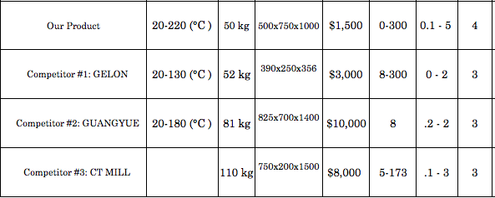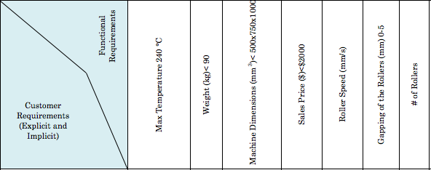
Figure 4 VG: Competitor Products Detailed Engineering Specifications

Concept Development

VI A. Methodology
Background research was done on calendaring systems and an analysis on competitive product information. This will give us incite on the new calendaring machine and for brainstorming ideas on the design concept and development. A prototype will be tested to find out any maintenance issues and for easy temperature and speed control. The new product will be helpful to universities and research institutions as well as current and future scientists and engineers.

VI B. Functional Decomposition
Functional decomposition determines the significant components and sub-functions our new product needs. The four sub-functions for the heated calendaring system are the rollers, motor, and temperature and gap sensors. These functions will determine what polymer materials can be processed into thin films. Figure 1 V1 B shows the conceptual design of what a calendering system revolves around.

Figure 1 VI B: Conceptual Design of a Calendering Machine

Figure 2 VI B: Conceptual Design Break Down

VI C. Sub-function I Heated Roller
The purpose of the heated roller in our system is to be able to process different types of thermoplastics. The thermoplastics will go in through the nip of the rollers and forced to a predetermined thickness creating a thin sheet of the desired thermoplastic. The heating of the rollers allows the thermoplastic to be heated to a pliable temperature for easy processing. Without the rollers there is no calendaring system
- Design Constraints
  - Cost
  - Sensitivity
  - Range
  - Durability
- Concept Variants
  - Durashell
  - Equatherm
  - Custom Roller
- Selection Process

VI C1. Heat Roller Design Constraints
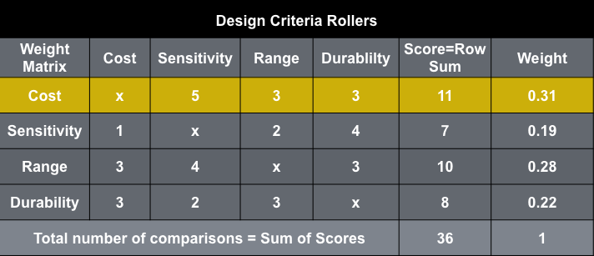
Table 1 VI C1 : Design Criteria for Heated Rollers

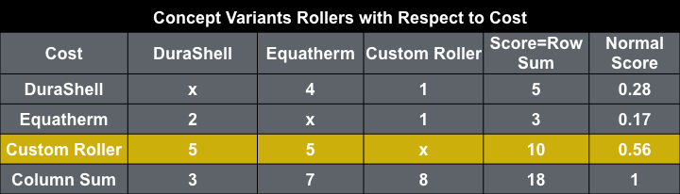
Table 2 VI C2 : Concept Variants with Respect to Cost
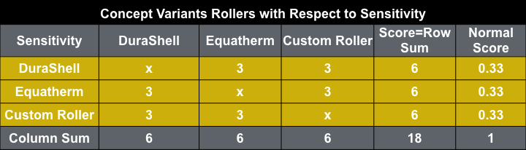
Table 3 VI C2 : Concept Variants with Respect to Sensitivity

VI C3. Heated Roller Selection Process & Identifying Winning Selection
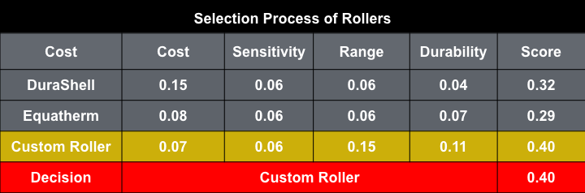
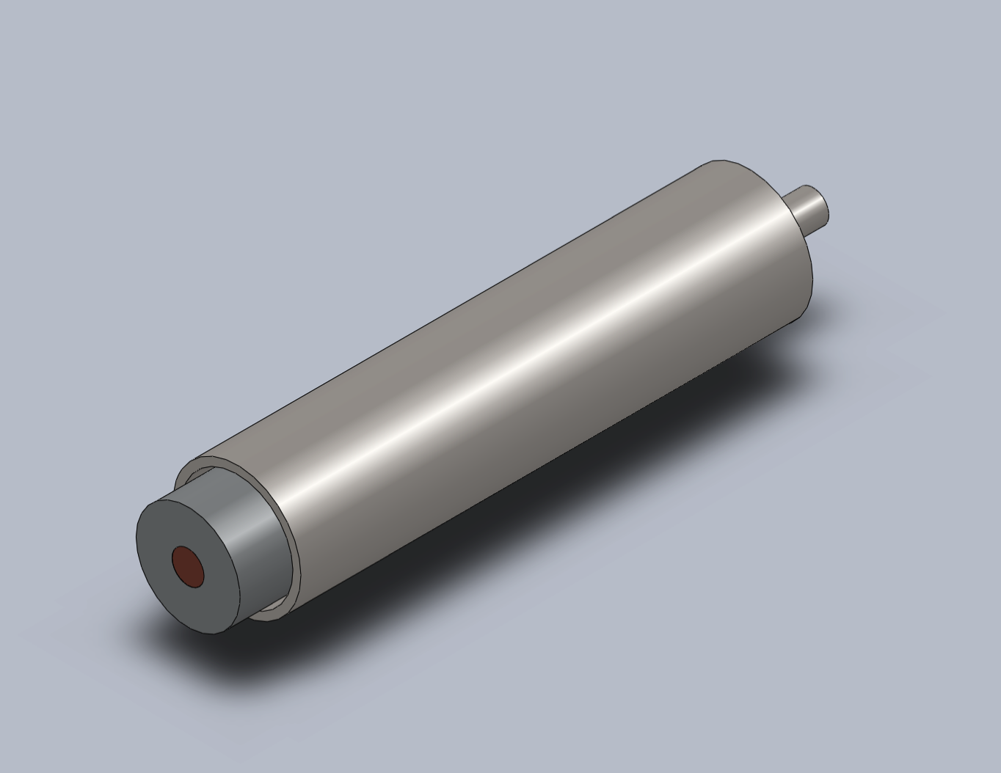
Figure 1 VI C3: Custom Heated Roller

VI D. Sub-function II Gaping Sensor
Design Constraints
  - Operating Temperature
  - Sensitivity
  - Range
  - Cost
- Concept Variants
  - Vernier Caliper
  - eddyNCDT
  - GapControl
- Selection Process

VI D1. Gaping Sensor Design Constraints
Table 1 VI D1 : Design Criteria for Gap Sensors

27

VI D3. Gapping Sensor Selection Process & Identifying Winning Selection

Table 6 VI D3 : Selection Process of Gap Sensors

Table 6 VI D3 above shows the Vernier Caliper as the clear winner of the selection process amongst the three gap sensors considered. Its outsized advantages in costs, range, and durability make the Vernier Caliper the most cost efficent and verstaile choice for our calendering machine. A standard digital Vernier Caliper is shown below in Figure 1.
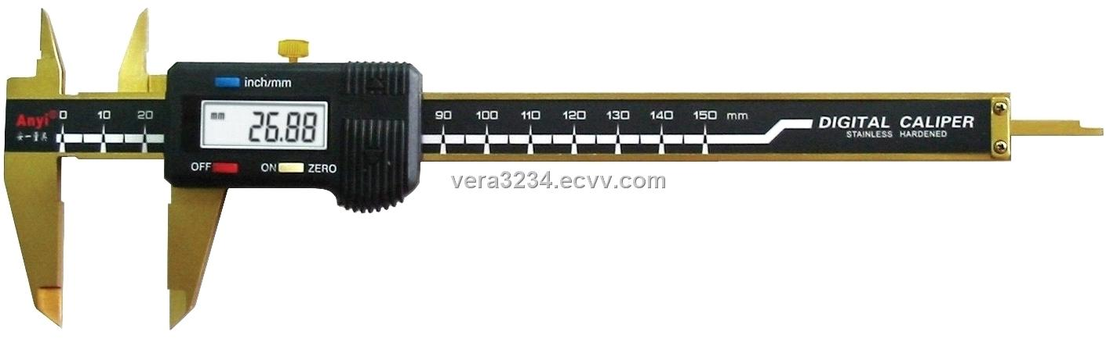
Figure 1 VI D3 : Vernier Caliper.

VI F. Sub-function IV Thermo-Sensors
Design Constraints
  - Cost
  - Sensitivity
  - Range
  - Accuracy
- Concept Variants
  - Thermocouple
  - Thermistor
  - Silicon Based
Selection Process

VI F1. Thermo-Sensors Design Constraints
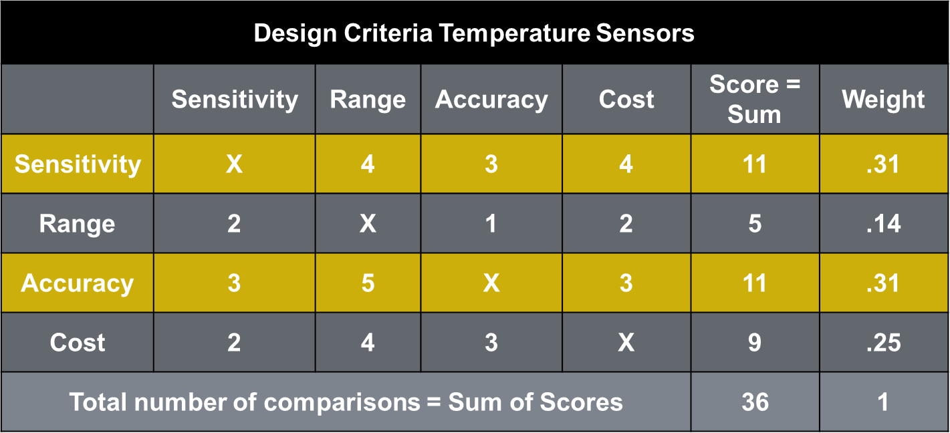
Table 1 VI F1 : Design Criteria for Temperature Sensors
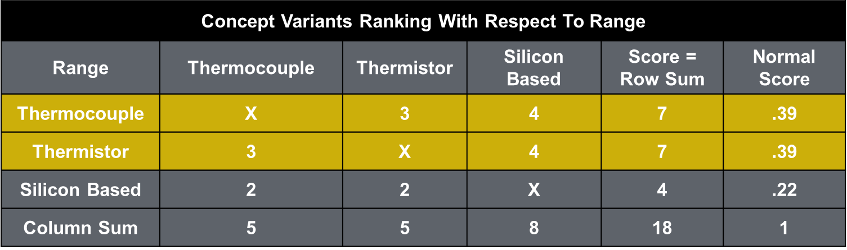
Table 3 VI F2 : Concept Variants with Respect to Range

Table 3 VI F2 depicts the temperature sensor with the best range. It was determined that with a range of -100 to +400 °C, the thermocouple and thermistor sensors were both equal in score.

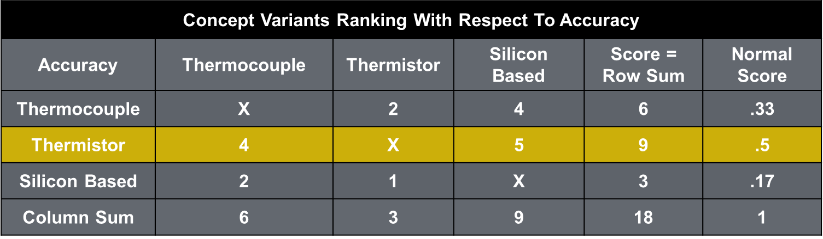
Table 4. VI F2 : Concept Variants with Respect to Accuracy

Table 4 VI F2 compares the accuracy of the temperature sensors that were researched. The thermistor has a clear advantage with a perfect accuracy of ± 0.1 °C.
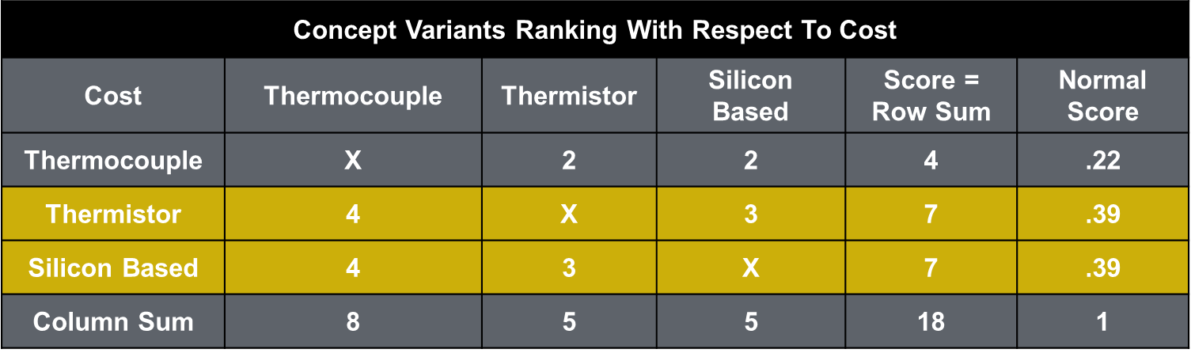
Table 5 VI F2 : Concept Variants with Respect to Cost

VI F3. Thermo-Sensors Selection Process & Identifying Winning Selection
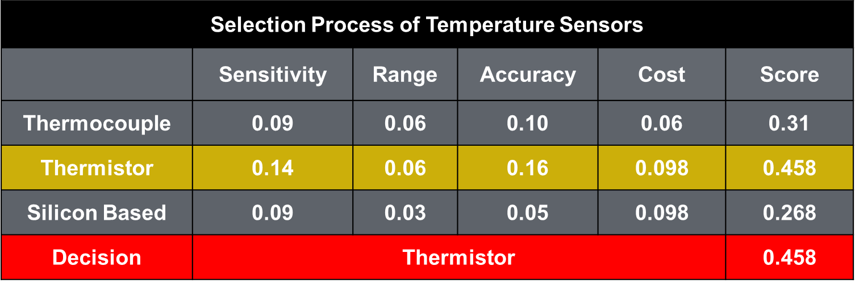
Table 6 VI F3 : Selection Process of Temperature Sensors

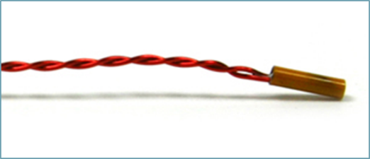
Table 6 VI F3 demonstrates that the thermistor temperature sensor was the clear winner of the three sensors researched for the heated calendering system (Shown in Figure 1 VI F3). The thermocouple and silicon based sensors had similar advantages to the thermistor in the criteria for cost and range but the thermistor prevailed in accuracy and sensitivity above the rest making it the best decision. The thermistor temperature sensor has a range from -100 to +400 °C, an accuracy of ± 0.1 °C, a very high sensitivity, and a cost between $ 2 to $10. The thermistors inexpensive pricing was also a great advantage for our heated calendering system since four thermistors are needed.
Figure 1 VI F3 : Thermistor Sensor

VI H. 3D Rendering of the Proposed Design, Complete with Dimensional Detail
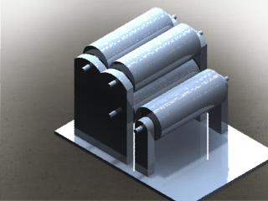
Figure V1 H1: Initial Design

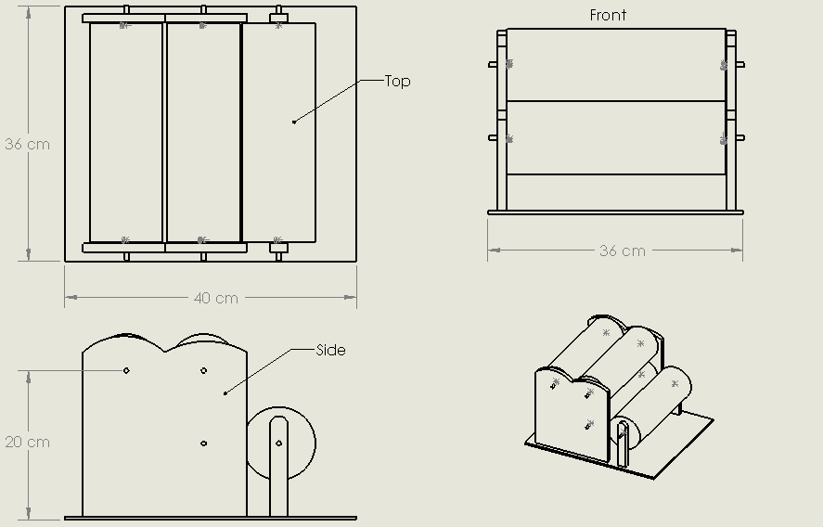
Figure V1 H2: Dimensions

Design Embodiment

VII A. Engineering Analysis
For our calendering machine there are many different aspects that we must look into in order to design our product. Looking into how a calendering system works it produces a certain thickness of film so what produces the film? The rollers produce the film and before the rollers produce the film they must be made first and engineering must go into analysis these rollers. What do the rollers need?
- Heated rollers
- Pressure between the rollers and the film
- Power to move the rollers
- Flow of material through rollers.
So these are aspects of the system that must be addressed and can be broken down into these core subjects of engineering:
- Heat Transfer
- Fluid Mechanics
- Solids of Materials
- Machine Elements
- Dynamics
Before studying the dynamics of the system or the flow of the materials through the rollers. Machine Elements and Heat Transfer analysis must be used in order to chose the material to make the roller and transfer heat uniformly to the surface of the rollers.

VII A1. Identification of Core Engineering Topics & Related Equations
Topics | Equation
Heat Transfer Rollers | $$Q_{Convection}=hA\left(T_{s}+T_{a}\right) Heat Transfer Convection$$  $$Q_{Conducion}=-kA\left(\frac{∂T}{∂r}\right) Heat Transfer Conduction$$  $$q=UAΔT_{ln} Overall Heat Transfer (Parallel Flow)$$  $$R_{t1,cond}=\frac{\ln\left(\frac{r_{Al}}{r_{Cartridge}}\right)}{2πk_{Al}L}$$  $$R_{t2,cond}=\frac{\ln\left(\frac{r_{St,i}}{r_{Al}}\right)}{2πk_{TG}L}$$  $$R_{t3,cond}=\frac{\ln\left(\frac{r_{St,0}}{r_{St,i}}\right)}{2πk_{St}L}$$  $$R_{t4,conv}=\frac{1}{hA}$$  $$R_{tot}=ΣR_{t1,t2,t3,t4}$$  $$Q=\frac{∆T}{R_{tot}}=\frac{T_{cartridge}-T_{∞}}{R_{tot}}=\frac{T_{H}-T_{Al}}{R_{t1,cond}}=\frac{T_{Al}-T_{St,i}}{R_{t2,cond}}=\frac{T_{St,i}-T_{St,o}}{R_{t3,cond}}=\frac{T_{St,o}-T_{∞}}{R_{t4,conv}}$$
Machine Elements | $${Re}_{D}=\frac{VD}{v}=\frac{ρVL}{μ∀c} Reynold^{'}s Number$$  $$ω=\frac{V}{r}$$  $$ω_{1}r_{1}=ω_{2}r_{2}$$  $P=\frac{N}{P_{d}}$ (Pitch equation)  $$F_{r}=\frac{mV^{2}}{r}$$  $$L_{p}=[R\left(h_{o}-h_{f}\right)-\frac{(h_{o}-h_{f})^{2}}{4}]^{1/2}$$  Or  $$L_{p}=\sqrt{R∆h}$$  $P=\frac{F_{r}}{bL_{p}}$ (Specific roll Pressure)
Table 1 VII A1: Equation used for Engineering Analysis

VII A2. Engineering Analysis complete with Tables & Graphs Heated Transfer
One of the key components for the calendering machine to function properly is to have the surface of the roller able to hit a range of different temperatures preferably from 0-220 degrees Celsius. Since the rollers that are going to be used are customized we had to find a heating source that would allow us to rotate the roller and heat up the system to a desired temperature. The heating element chosen to do the analysis was a cartridge heater from Grainger that can operate to a max of 500 Watts. The cartridge heater has a length of 8 inches and a diameter of 0.50 inches. This would essentially be the core of the rollers, but in order for the cartridge heater to work effectively it must have metal contact because if it is exposed to air the heating element will burn out. So we will need another cylinder around it with good thermal conductivity properties to propagate the heat. Now the cartridge heater has wires to supply power to the element, and we cannot have the element wires getting tangled so the cartridge heater and the cylinder encompassing it must remain as a fixed axis. To achieve this we will be using a bearing that will attach the cylinder into the inner diameter of the bearing, while the outer diameter will carry a steel roller, which will allow the outer shell to roll and give heat to the surface through thermal conductivity. Now air is a really good insulator so in-between the gap of the cylinder and the inner diameter of the steel roller will be thermal grease providing lubrication and a medium for heat to travel to the outer diameter of the steel roller. The heated rollers can be expressed in four different radii, which are the cartridge heater (r_{cartridge}), aluminum (r_{Al}), inner steel (r_{st,i}), and outer steel (r_{st,o}). These radii are important for solving this heat transfer problem through a thermal circuit. Heat transfer rate, q , equals the temperature difference divided by the total resistance seen in the equation below.
$$q=\frac{∆T}{R_{tot}}$$
R_{tot} is the total resistance of the system, which will compose of the conductivity resistance of the cylinder and the free convection resistance outside of the rollers. Figure 1 VII A2 shows the cylinders and the equation for thermal conductivity of a cylinder.
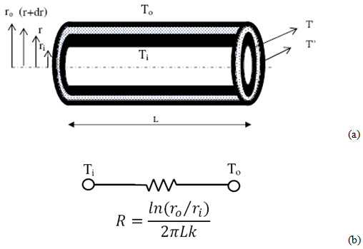
Figure 1 VII A2: Heated roller with resistance of thermal conductivity

The thermal resistance for free convection can be seen in the equation below where h is the convection coefficient and A is the surface area of the steel cylinder.
$$R_{conv}=\frac{1}{hA}$$
The total resistance of the system is composed of the four resistances R_{t1,cond}, R_{t2,cond} R_{t3,cond,} and R_{conv} which are the resistance of the aluminum rod, thermal grease, steel rollers, and the ambient air respectively also shown in the equations below.
$$R_{tot}=R_{t1,cond}+R_{t2,cond}+R_{t3,cond}+R_{t4,conv}=\frac{\ln{\frac{r_{Al}}{r_{cartridge}}}}{2πk_{Al}L}+\frac{\ln{\frac{r_{st,i}}{r_{Al}}}}{2πk_{grease}L}+\frac{\ln{\frac{r_{st,o}}{r_{st,i}}}}{2πk_{st}L}+\frac{1}{hA}$$

We want to achieve the best heat transfer to the surface so we will treat the core of the fixed axis to be calculated with different material type we originally use aluminum but will be testing copper, brass, and gold to see the different effects. Using these equations we can now calculate what the temperature at each point of the roller will be in Figure 2 VII A2.

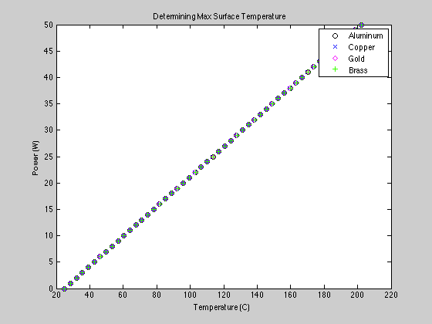
Figure 2 VII A2: Heat transfer calculation
From the data it can be seen that the temperature is virtually the same no matter what core is used and this could be to the distance of the cores. So the optimal chose will be the most cost efficient one which would be the aluminum rod.

VII A3. Engineering Analysis complete with Tables: Machine Elements
In order for the calendering machine to be able to properly function, it is important to have the correct motor that will be able to transfer the appropriate velocity to each roller. With this being said a standard motor is set to a fixed constant velocity that it will output, which can only be reduced by set of a couple of gears. A controlled voltage input to the motor is also another way to reduce velocity output, but in our case that just isn’t enough considering that or velocity needed is severely slow. So our motors output velocity will undergo a series of gears to be able to reach our desired maximum output velocity.
$$ω=\frac{V}{r}$$
Equation 1: Angular velocity
First, since most motors give you an output form of angular velocity, the angular velocity equation is used to calculate the output velocity given by the motor. Where V is the velocity, r is the radius of the gear, and $ω$ is the angular velocity. Like I said before, our velocity need is very low so by calculating the maximum velocity provided by the motor we will be able to solve for the second gear’s radius or angular velocity using the following equation:
$$ω_{1}r_{1}=ω_{2}r_{2}$$
Equation 2: Angular ratio equation
Where $ω_{1}r_{1}$ are the angular velocity and radius of the first gear and $ω_{2}r_{2}$ are the angular velocity and radius of the second gear. In order to decrease the velocity, the second radii must be larger than the first. Manipulating equation_ to solve for velocity instead of angular velocity can prove this. One our desired maximum velocity is accomplished; this exact same equation is used to be able to calculate for our 3 important gears that will be driving our rollers. Our tallest gear will be our driver, which will have the largest radius with the lowest angular velocity. The following two gears will be the driven. For the second gear it will have smaller radius than but a higher angular velocity than the driver gear. As for last gear, it will have to be the smallest of all 3, since we want it to produce the highest angular velocity of all three. Reason for this analysis is because of our Z arrangement of rollers. Our film needs to flow smoothly through each roller and in order for this to occur, the roller with a higher angular velocity will be able to pull the film in the direction it need to go.
$$P=\frac{N}{P_{d}}$$
Equation 3: Pitch
Once all diameters for each gear is set, it is important to make sure each gear will smoothly coincide with one another. The above equation is import in doing so where P is the pitch, N is the number of teeth, and $P_{d}$ is the pitch diameter.
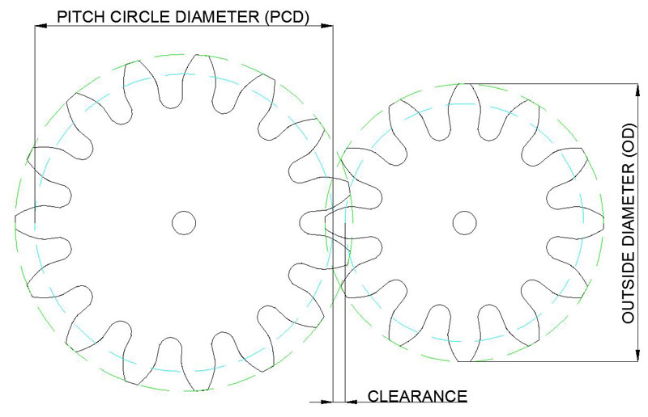
Figure VII A3: two gears in contact

Gear | Pitch | Number of Teeth | Outside Diameter (mm) | Pitch Diameter (mm)
Driver | 16 | 32 | 54 | 50.8
Driven | 16 | 23 | 39.7 | 36.5
Driven | 16 | 15 | 26 | 23.8
Table V11 A1: Calculated values for gear analysis
The table above shows the parameters of the gears need for our calendering system to function properly. These desired numbers were able to be calculated using the pitch formula.
Since our calendering system will have rotating rollers, the main source of drivers that will cause the rollers to rotate will come from our gears. The rotation of the rollers along with the width and thickness of the film being inputted will determine the specific pressure coming from each roller.
$$F_{r}=\frac{mV^{2}}{r}$$
In order to calculate the pressure the radial force of the roller has to be determined first. The equation above shows the relationship needed in order to calculate the radial force of the roller where $m$ is the mass, $V$ is the velocity, and $r$ is the radius.
The second important factor needed in order to calculate the specific pressure is the contact length the roller has on the material. This calculation is obtain by using the equation below:
$$L_{p}=\sqrt{R∆h}$$
Where $R$, is the radius of the roller and $∆h$ is the difference in thickness inserted into the roller. By taking the square root of the radius and film thickness relationship, the contact length is obtained.
Finally once both important factors are obtained, the specific pressure is simply calculated by using a basic pressure formula of force over the area.
$$P=\frac{F_{r}}{bL_{p}}$$
Where $F_{r}$ is radial force calculated with the mass, velocity input, and radius. $L_{p}$ Is the contact length calculated and b is the width of the polymer film.
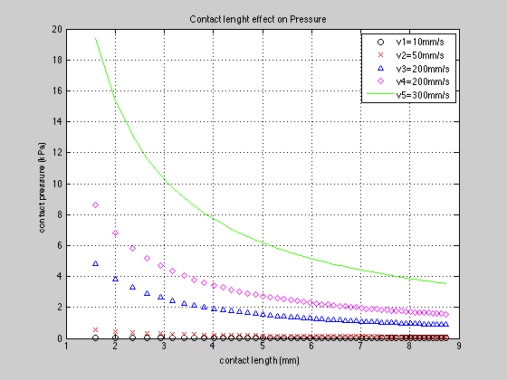
Figure AII V4: Contact length effect on pressure

The figure above shows the relationship between the contact length and the contact pressure. As it is shown the contact pressure decreases as the contact length increases. This occurs due to the pressure formula, where the width of the film times the contact length divides the pressure force. Since the width of the film is constant the increase in the contact length has a greater reduction on the pressure force. Also different variations of the velocity increase and decreases the contact pressure induced on the film.

VII B. Design for Manufacturability
Now that the analysis is done for our calendaring system we can now devised how we are going to manufacture every component and assemble them together for the final product. Once the final product is completed a step-by-step instruction can be given for mass production of the product.

VII B1. Preparing Parts & Components
First we needed to cut two rods of 2-inch diameter length to 9 inches one of steel and another of aluminum seen below in Figure 1 VII B1 show respectively.
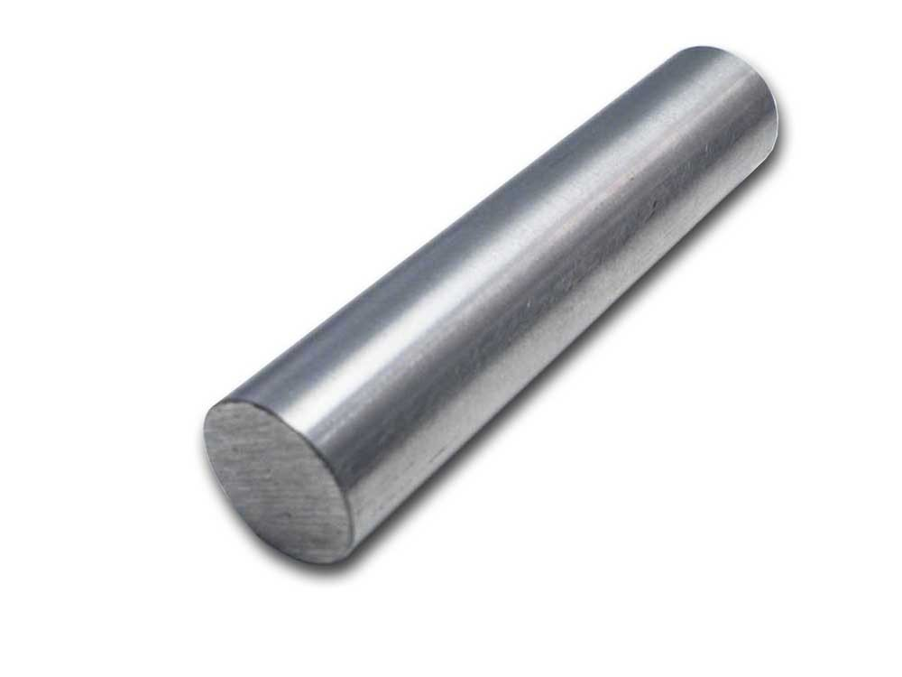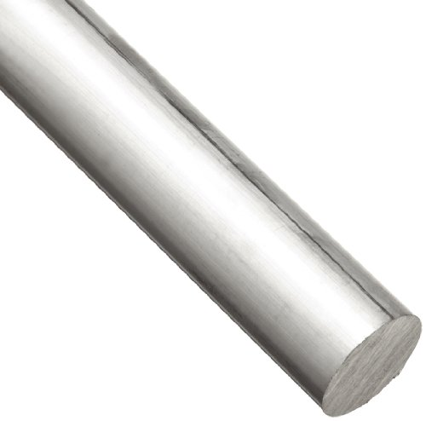
Figure1 VII B1: Steel and Aluminum Rods
Once the rods are cut to these exact measurements we can start milling down these two parts to the set dimensions below shown in the drawing in Figure 2 and 3 VII B1.
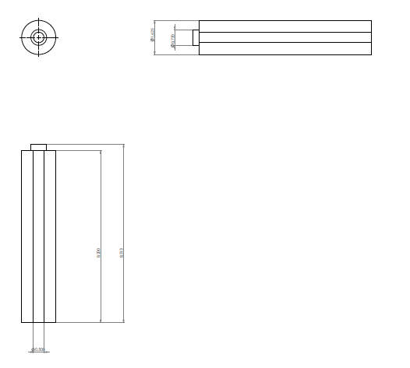
Figure 2 VII B1: Aluminum Rod Drawing
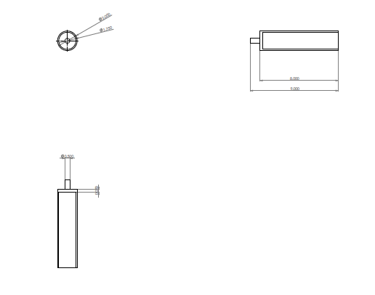
Figure 3 VII B1: Steel Rod
So from the 2-inch diameter rod shown in Figure 2 VII B1 the aluminum rod needs to be turned down to 1.625 inches with a final length of 8.5 inches but 0.3 inches of the length will be turned down to 0.75 inches. Then there will be a 0.5-inch diameter hole drilled into the center of the rod 8.2 inches of the way for a heating source to be placed into the hole. Below is the process of doing these steps chronologically to have an overall good part.
- Aluminum Rod
  - Cut 9 inches of aluminum round stock.
  - Use the lathc machine to face both ends of the rod to have a flat piece.
  - Use center drill to make a pilot hole in the center of the rod, switch out the center drill for a 0.5-inch drill bit to make a hole 8.2 inches deep into the rod.
  - Turn down the diameter of the whole rod to 1.625 inches.
  - Remove material from the rod where there is no hole using the facing method to have an overall length of 8.5 inches.
  - Then 0.3 inches into the length the diameter will be turned down to 0.75 inches for the bearing.
In Figure 3 VII B1 will be hollowed out to 1.75 inches only 8 inches of the way through there will be a wall thickness of 0.25 inches and on the other end there will be about an inch of rod sticking out that was turned down to 0.5 inches. Below is a detailed report of how this will be machined chronologically.
- Steel Rod
  - Cut 9 inches of steel round stock
  - Use the lathe to face both ends of the rod, and then with a center drill to make a pilot hole for the steel rod. Switch out to 0.5 inch drill bit and go 8 inches into the rod. Switch out to 1.625 drill bit and go 8 inches in. To achieve the final inner diameter a boring bar will be used to achieve precision of a 1.75-inch diameter.
  - Flip the piece to the other end and turn down 1 inch of length of the material to 0.5 inches using the lathe.
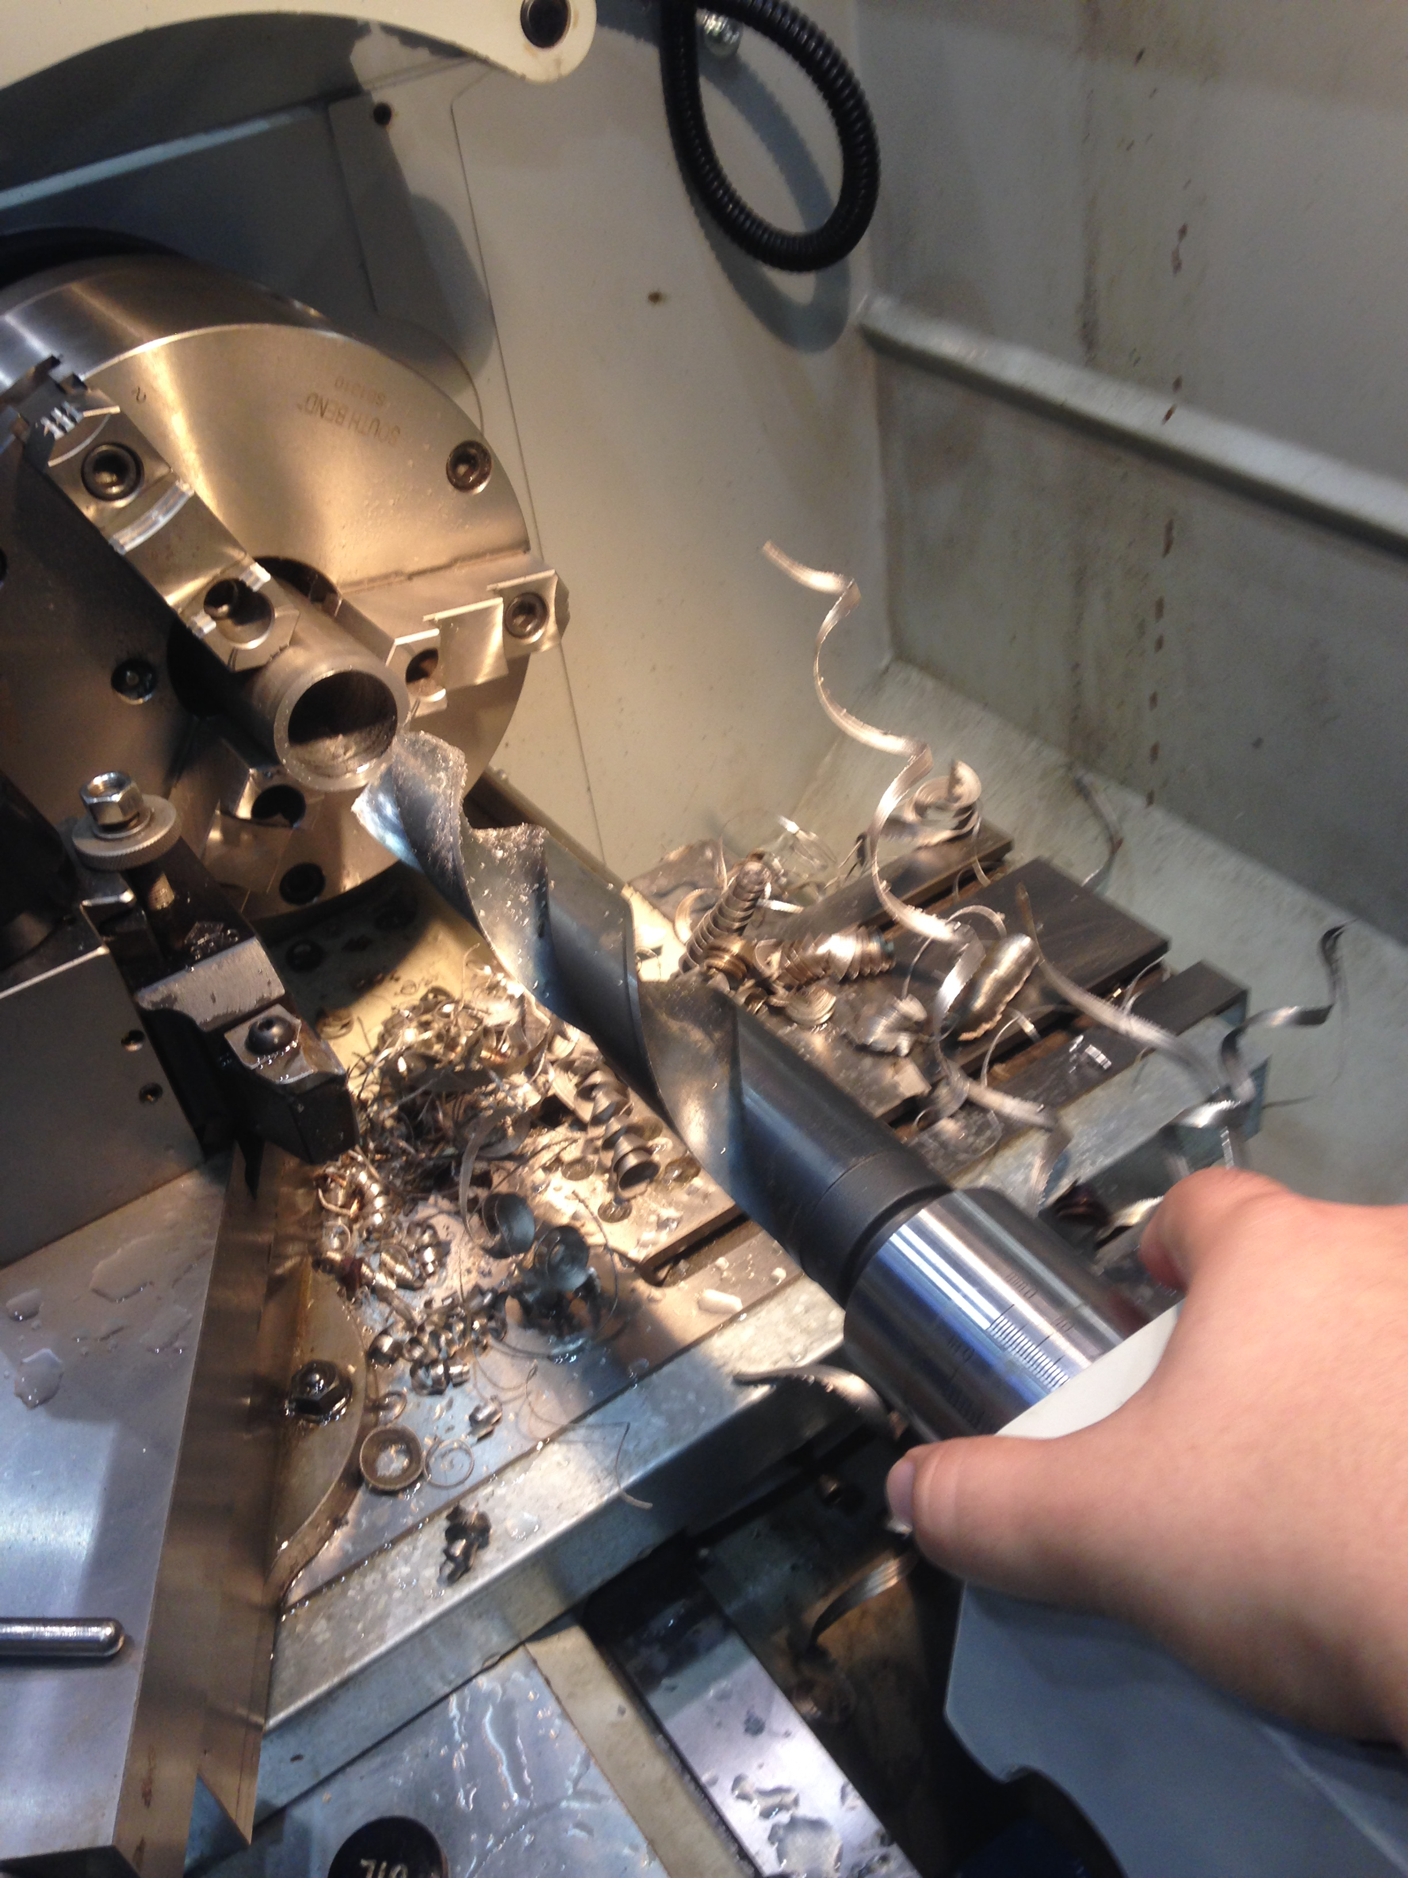
Figure 4 VII B1: Drilling out the steel rod
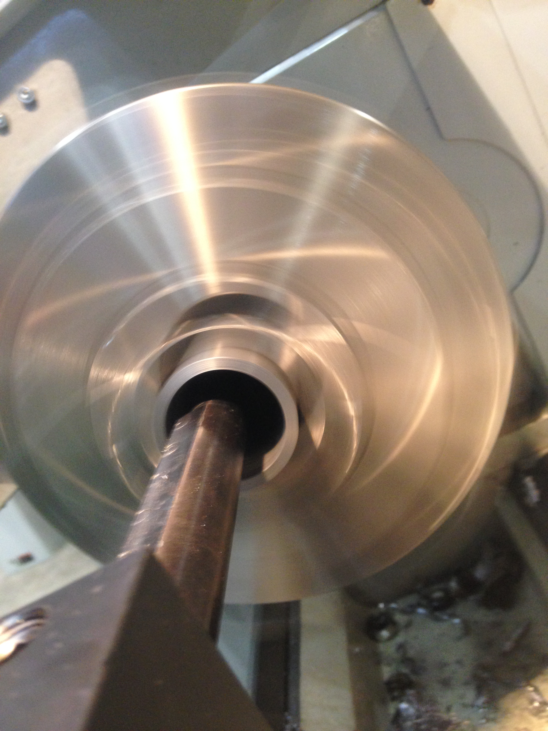
Figure 5 VII B1: Boring out steel rod
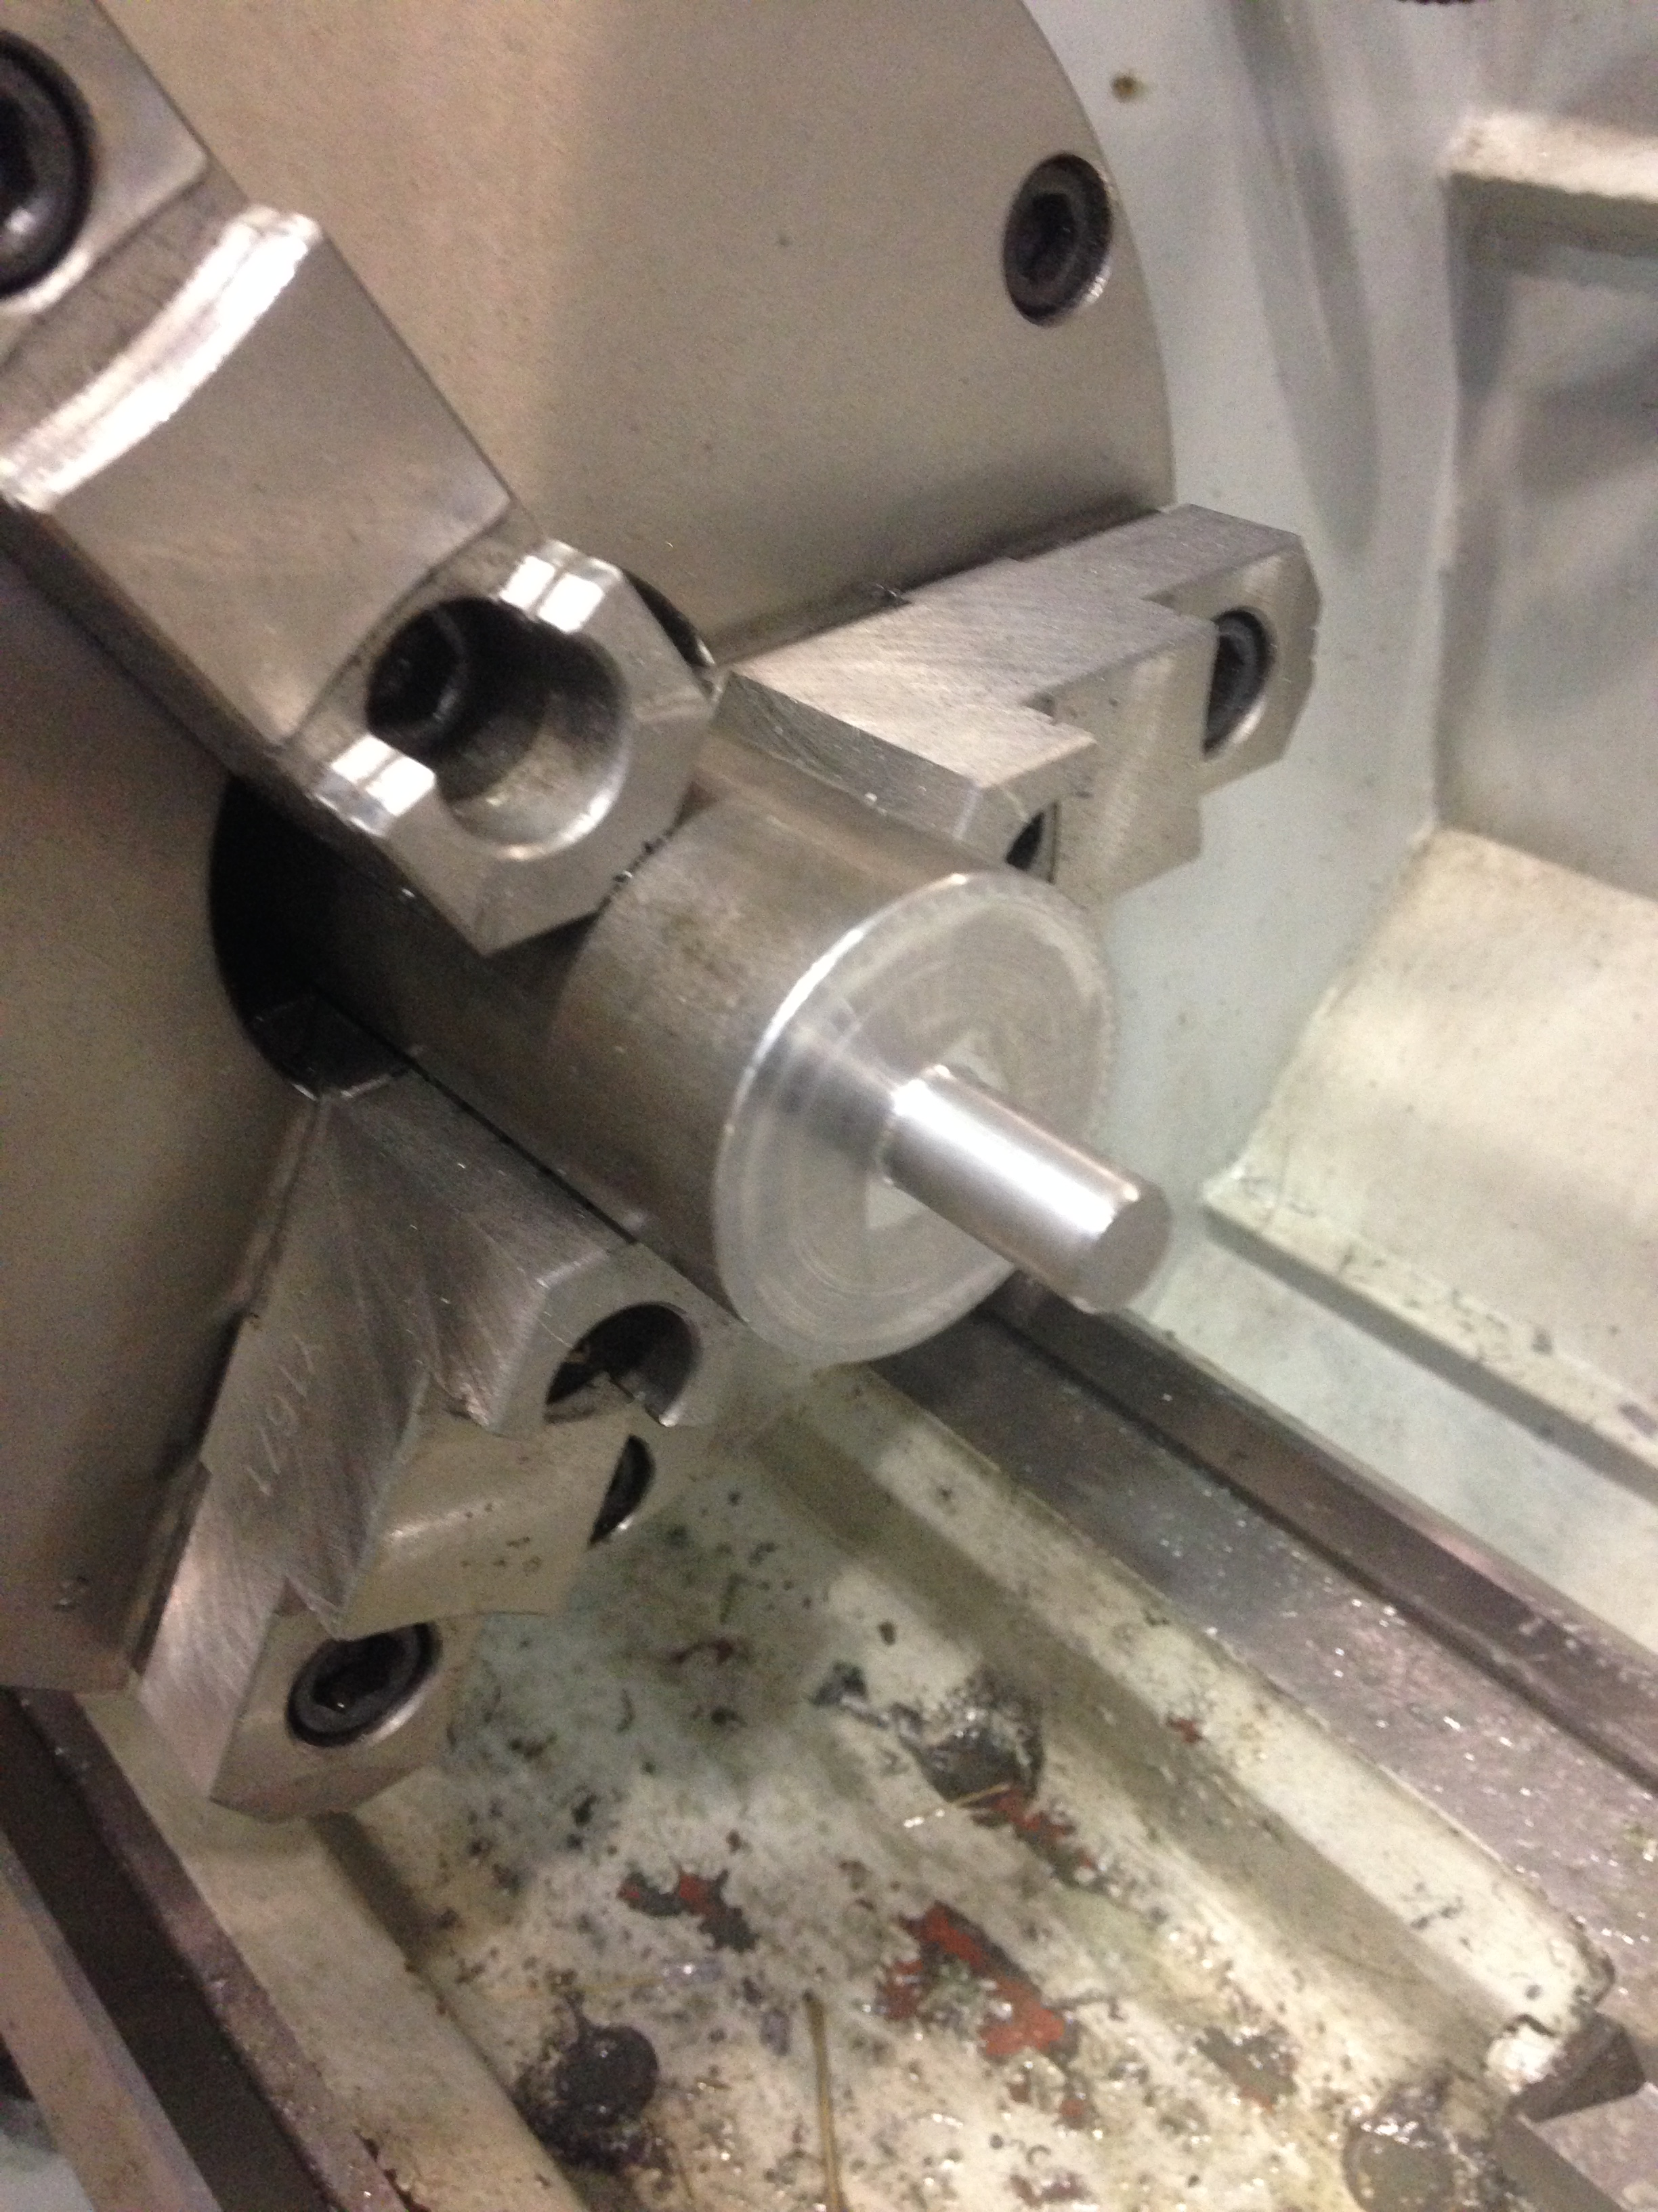
Figure 6 VII B1: Other end turned down to 0.5 inches
Once these components have been made we can start assembling the roller together.

VII B2. Assembly Process
Now that the two main components of the roller are done we must now press fit the bearing into the aluminum rod. Figure 1 VII B2 shows the aluminum rod press fitted into the bearing on one end with the cartridge heater inside the connecting lead wires are sticking out.
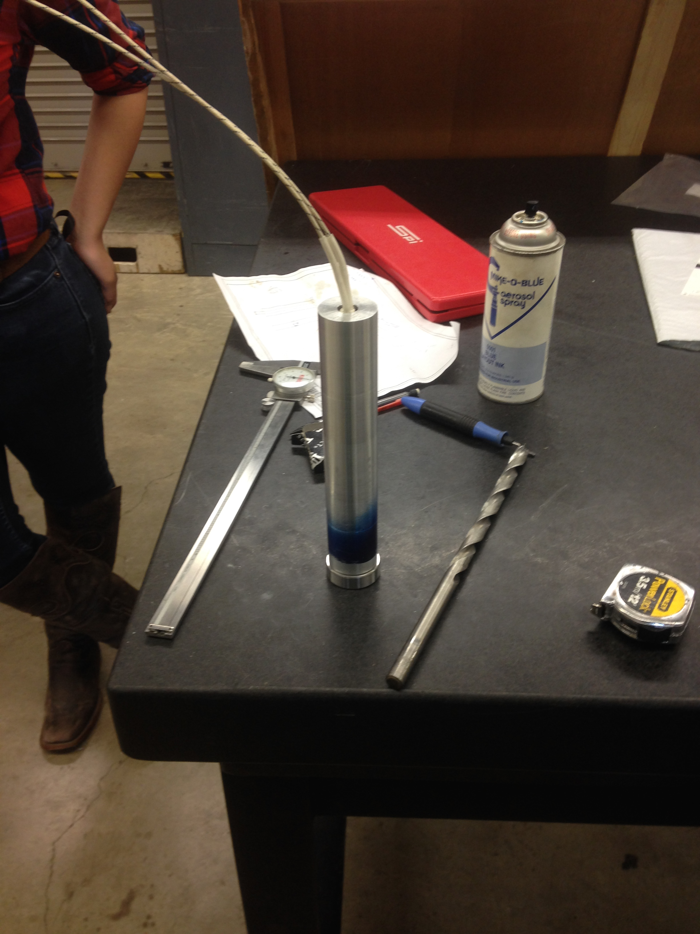
Figure 1 VII B2: Aluminum Rod Completed
Now we can press fit the aluminum rod into the steel roller through the use of a 50-ton press. As the cylinder is being press fitted into steel rollers thermal grease will be applied all around the cylinder so it can travel into the steel roller creating a thickness of thermal grease between the aluminum rod and the inner diameter of the steel roller. Figure 2 VII B2 shows the aluminum rod next to a grease gun used to lubricate the whole rod. Figure 3 VII B2 shows the steel rod being put into place filled with thermal grease as well to prepare for the press fitting of the aluminum rod. Figure 4 VII B2 shows the beginning and end of the press fitting.
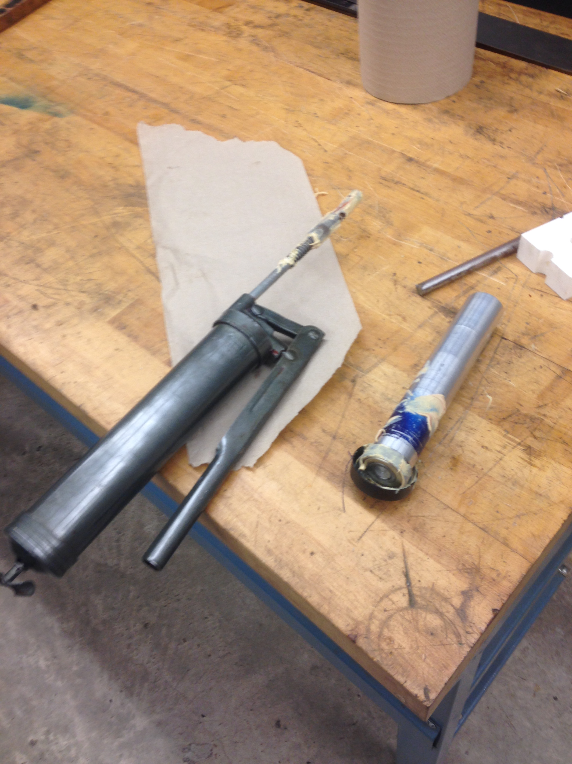
Figure 2 VII B2: Aluminum rod with grease gun
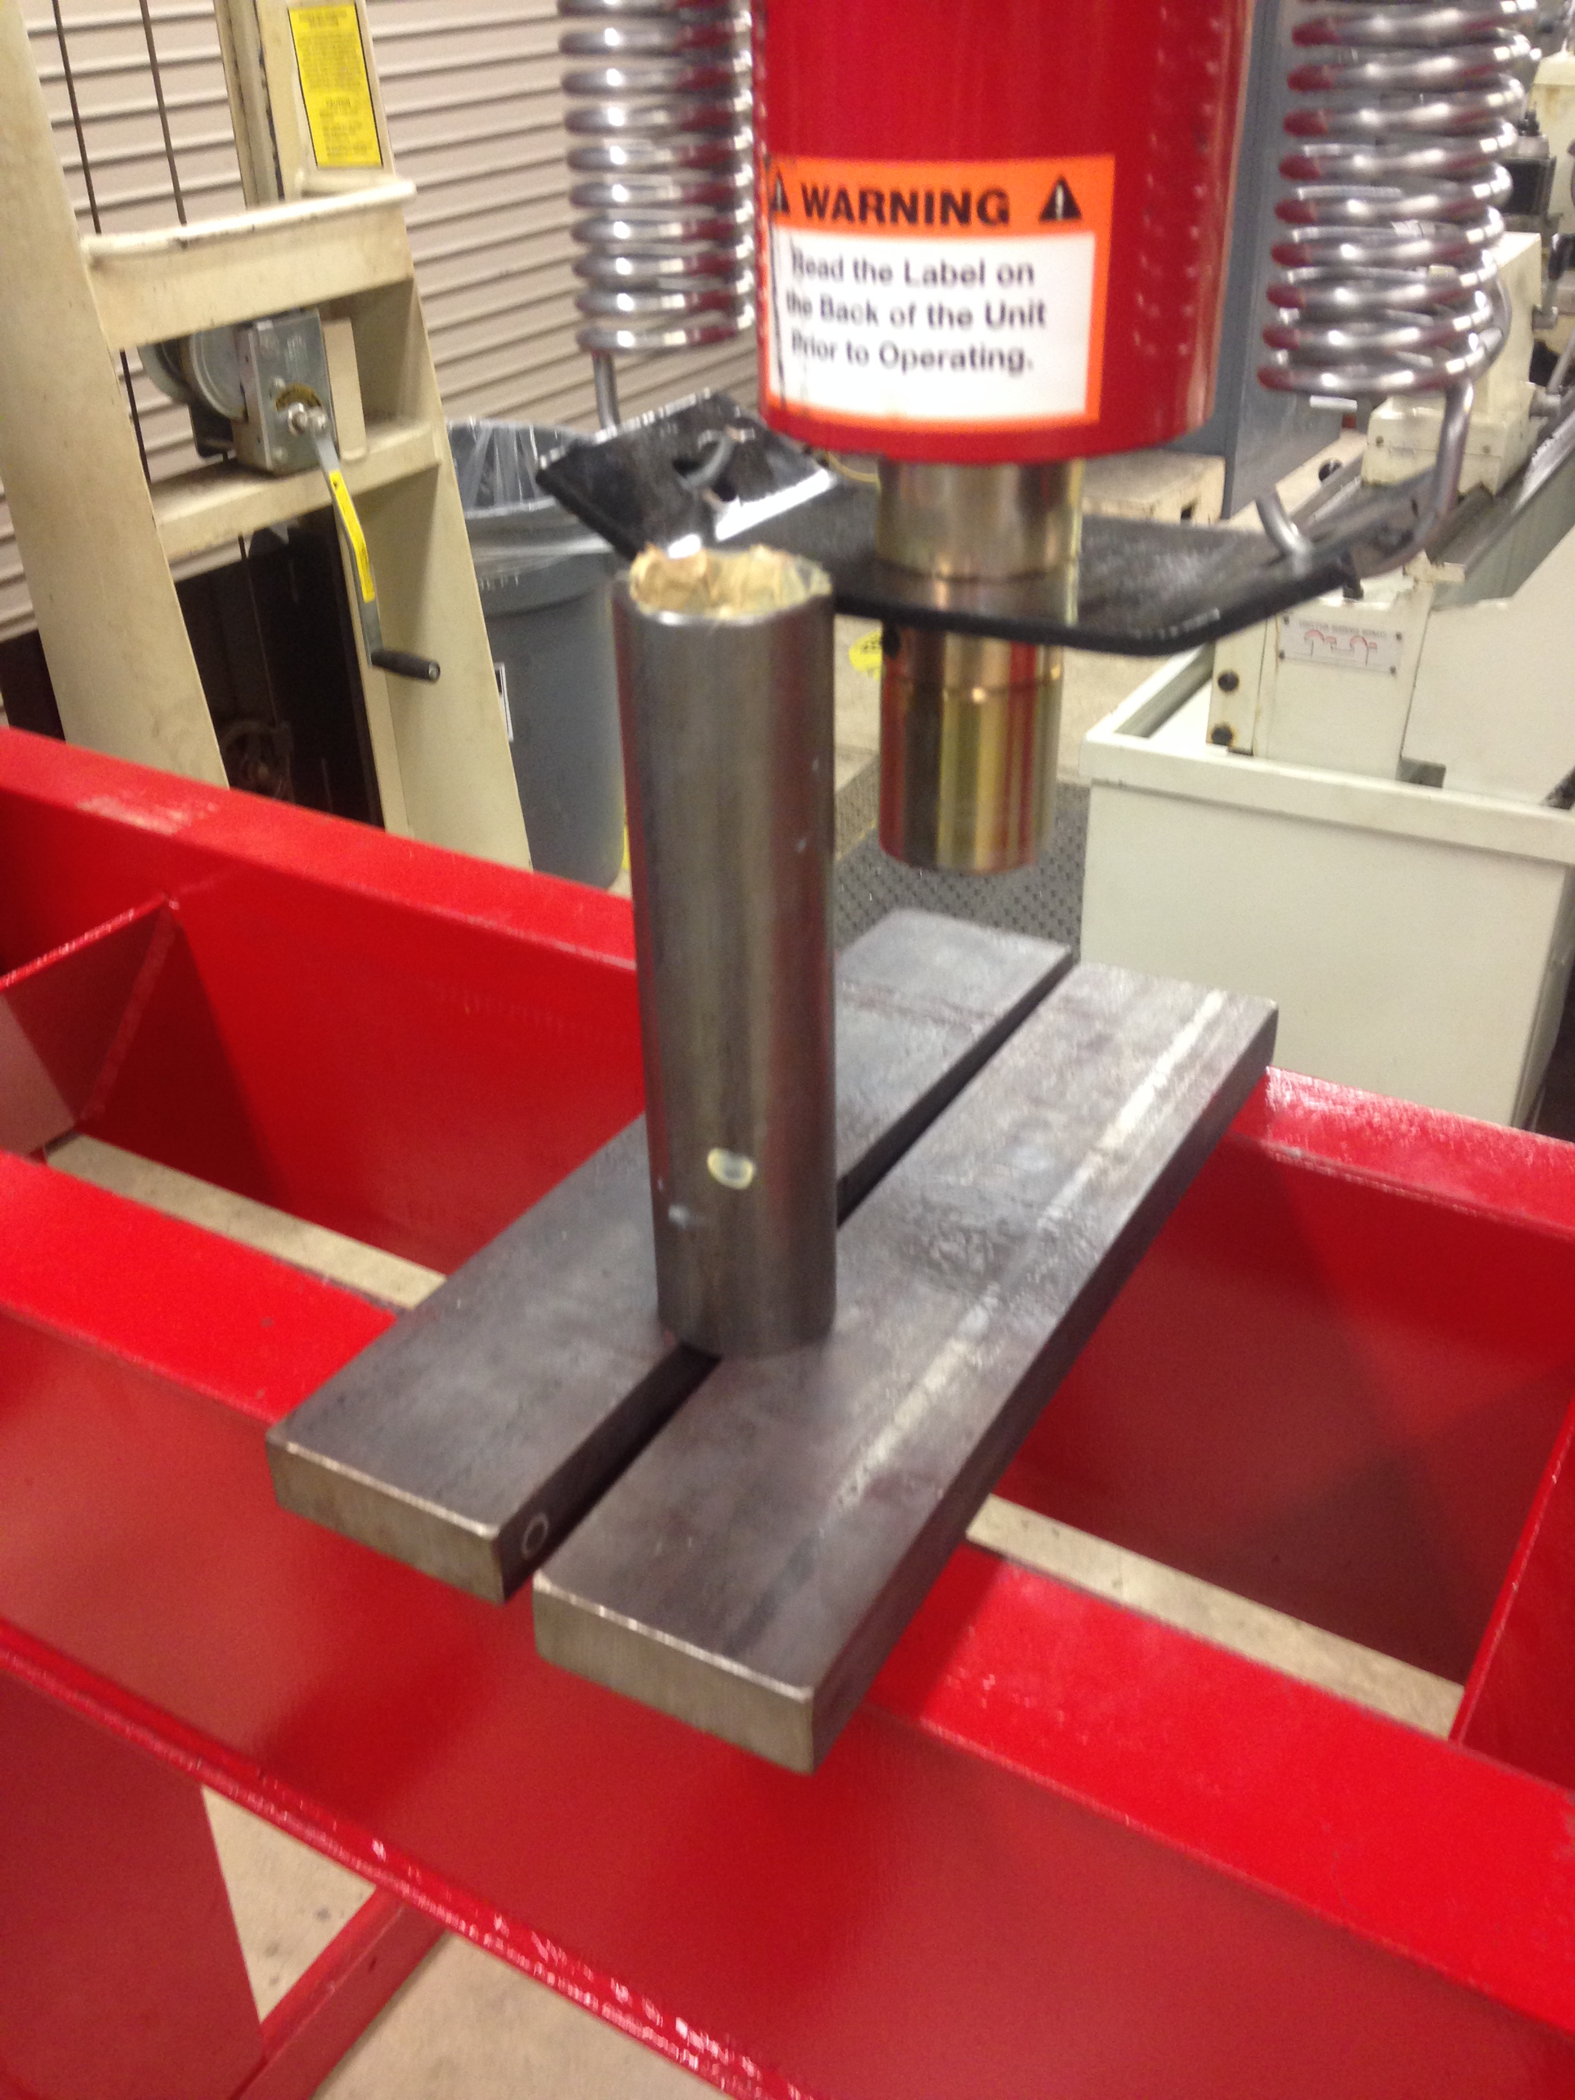
Figure 3 VII B2: Steel Roller with thermal grease

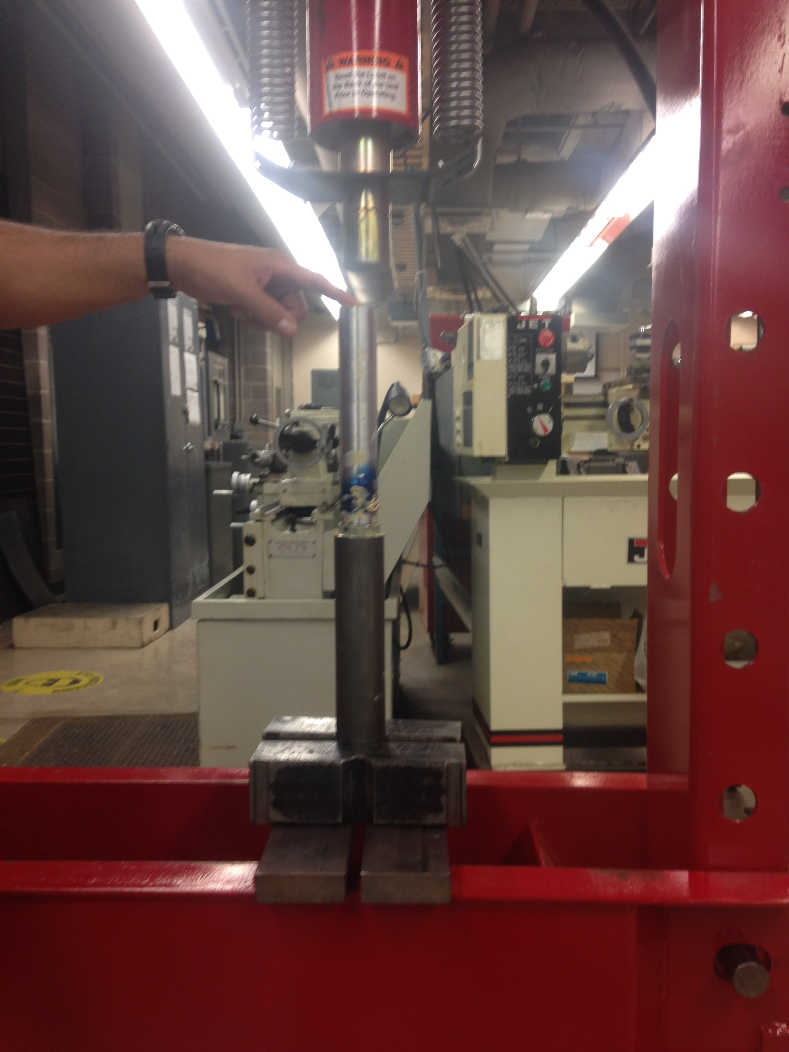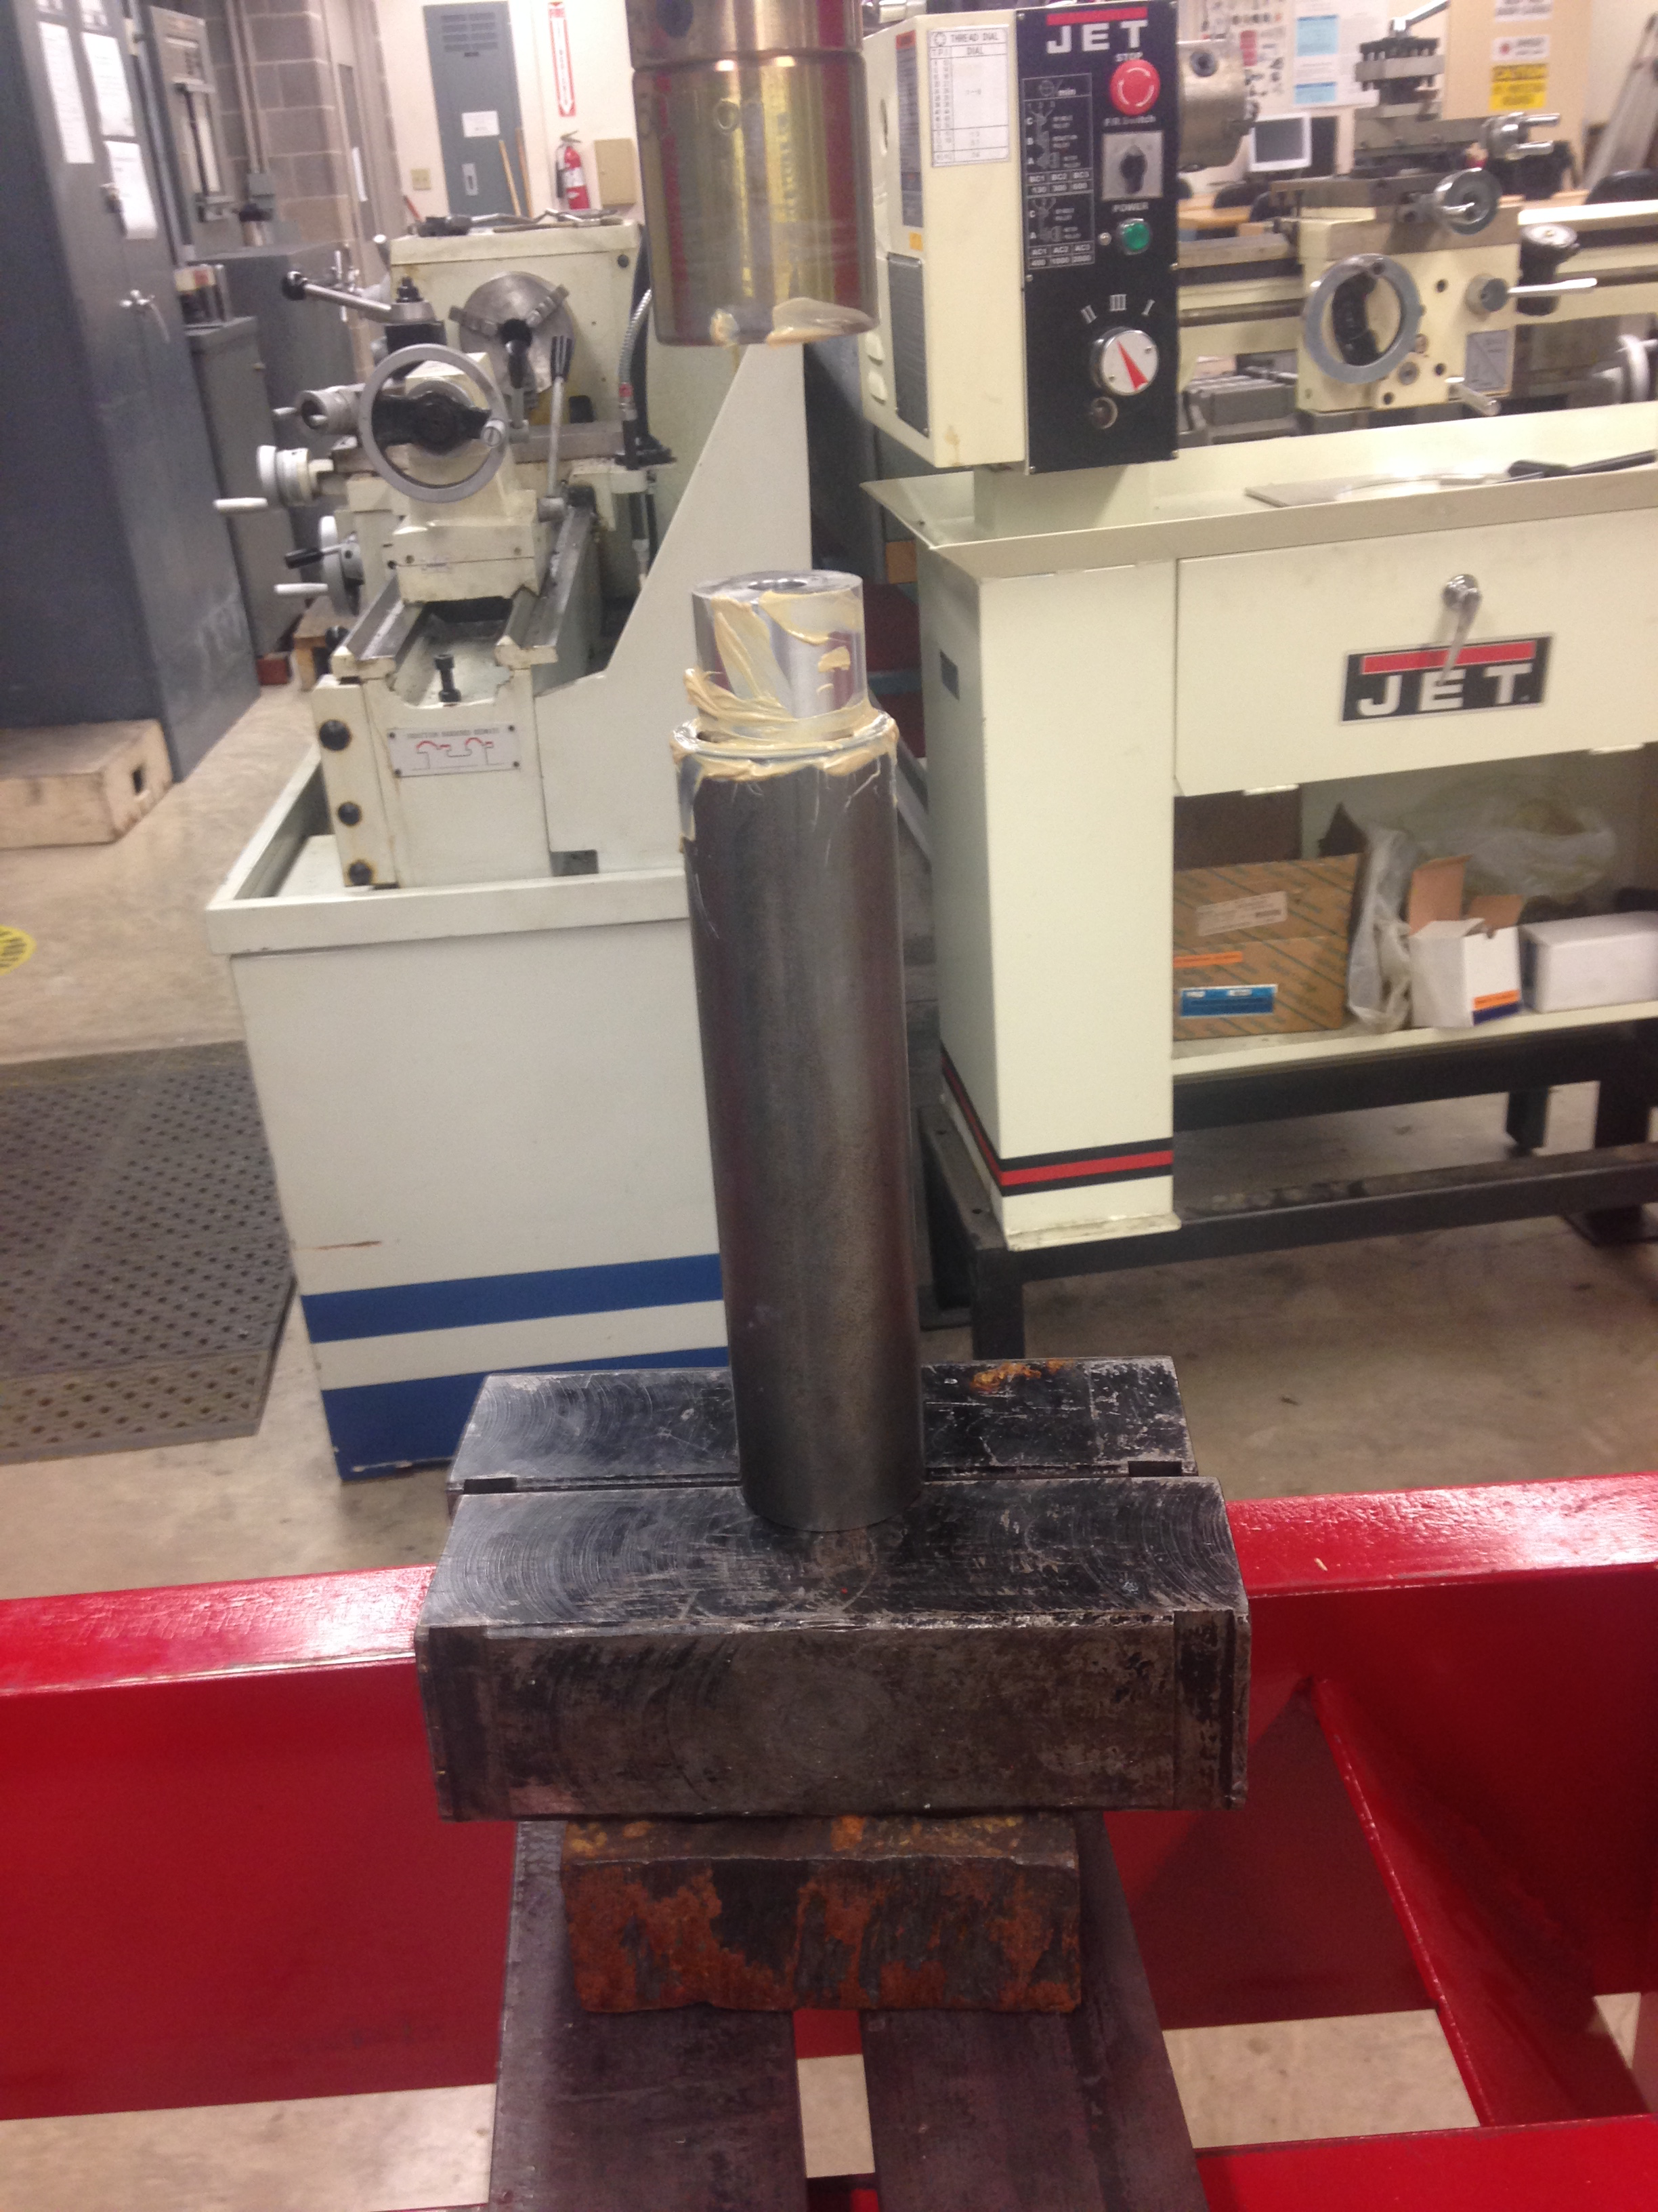
Figure 4 VII B2: Completed Heated Roller

VII B3. Manufacturing Process Document

Bill of Materials
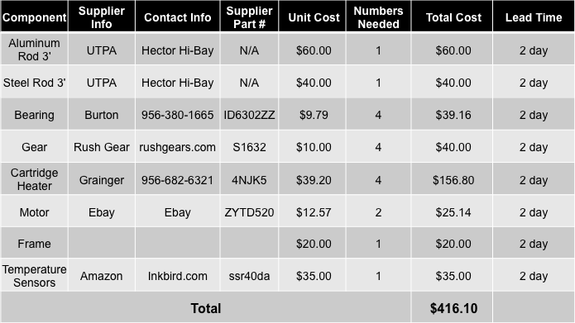
Table VIII: Bill of Materials

The table above displays the bill of materials for the entire product. As shown, the cartridge heaters are the most expensive part in our system with a total cost of $156.50. Lead-time for all materials is less than a week making it a time friendly product to assemble.

Design Validation

IX A. Test Protocols
Now that we have our system intact and are going to start making an assembly chain for mass production there is room for error in production and some parts may be no good and cause the system to not work properly. So how can we make sure that all of our systems are working correctly and have no glitches? We need to be able to test our product and make sure key components are working. Out of so many calendaring systems produced using probability and statistics we can test a product to see if its features are working correctly. The main components for the system that must be checked are the temperature of the rollers and of course the thickness of the film being produced is the correct thickness and quality. So when testing the product first the easiest form of testing is the heating of the rollers. Our system will have a PDI sensor, which controls the temperature of the surface of the rollers, but how would we know that the PDI sensor is working correctly. We would simply get a thermocouple and touch the surface of the roller and conform that the reading from the thermocouple is within 10 percent error of the actual reading being given by the PDI sensor.
For the thickness of the material we would have to test the system by producing a thin film of multiple types of thermoplastics. We would produce these different materials for example to a thickness of 1 millimeter. When is thermoplastic is produced we will measure the thickness to make sure that all of the materials hold that constraint of 1 millimeter thickness.
Once these two criteria have been met the calendaring system will pass inspection and the amount of calendaring systems that were within the probability portion that we were testing are fine. If the test protocol were a fail then all of those calendaring machines would have to be checked and fixed to meet the customer’s needs.

IX C. Economic Analysis
The engineering economic analysis covers the prototype and production cost as well as the pricing distribution. This will determine the retail cost vs. the production cost to see how much profit will be made from the mass production of the calendering system.

IX C1. Production Cost
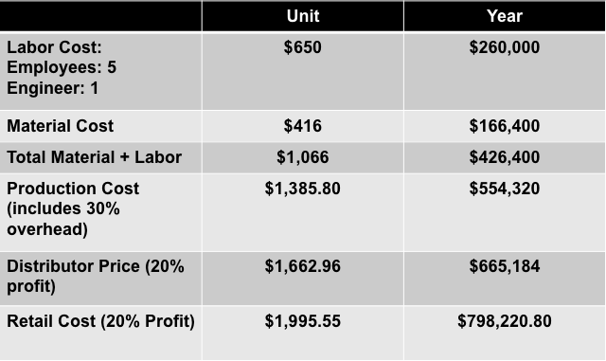

Summary
With an understanding of the calendering market and the potential customers that will buy small lab sized machines is crucial to creating a product and making a company that can build profit from a product. One must understand the potential competitive products out there and build of the competition to install features that are useful, needed, and better then the competitors to arouse the customer to buy our product versus there’s. With the use of a tool called a QFD we can summarize the customers needs/wants and the engineering specifications needed to carry out a useful product. The QFD also allows the comparison of all competitor products including ours and shows which aspects of the system are most important to attain because one would like to achieve everything the customer wants and needs but due to certain constraints some options may not be viable to use or add to the system. Now that a full understanding of the market and the customer we can now develop a concept for our calendering system that will give a base of how to make the system work and what it will compose of. Then a process selection can begin for parts or function need and compare to different equipment for example different temperature sensors such as a thermocouple or thermistor. One can compare the cost of each product to each other as well as its sensitivity, range, and accuracy. This can be propagated to different items as well for a selection process. Now an initial design is completed and can now perform an engineering analysis to make sure all the parts and dimensions need are viable for a working calendering system. We will have to analysis the heat transfer of the system, and the deflection of the rollers and run with different scenarios to have the best outcome of parts used and to make sure they can withstand the working conditions. After this is done we can then start fabrications of parts and testing which will eventually lead to mass production of the system to create a profitable company.

Reference:

- http://www.idspackaging.com/common/paper/Paper_320/calendering_wp.pdf
- http://www.mahloamerica.com/pdf/Mahlo Calendering Industry Application Expertise.pdf
- https://www.asdreports.com/news-1149/global-thermal-fluidheat-transfer-fluid-market-expected-reach-25-billion-2017
- http://www.appropedia.org/Polymer_calendering
- http://www.alibaba.com/product-detail/Li-ion-battery-lab-calendaring-machine_1815506686.html?spm=a2700.7724857.29.100.zeWagq
- http://www.edn.com/Home/PrintView?contentItemId=4368418
- https://en.wikipedia.org/wiki/Calender
- http://www.paratusindustries.com/calenders.htm
- http://www.vxb.com/page/bearings/PROD/inch/Kit7426?gclid=CIng8t2v8cgCFY-CaQod93QMqw
- http://www.southwestpolymersupplies.co.uk/rubber-processig-machinery/4588548501
- http://www.chareontut.com/TwoRollMill.htm
- http://www.uttamrubtech.com/calender-machines.html
- http://www.sut.ac.th/engineering/Metal/pdf/MetForm/03_Rolling%20of%20metals.pdf
- http://www.rushgears.com/tech-tools/part-search/gears/type/spur

